**Adding α to a total wealth portfolio**

Modern Portfolio Theory (MPT) has revolutionized finance since its development in 1952. MPT, or mean-variance analysis, is a mathematical framework for assembling a portfolio of assets such that the expected return is maximized for a given level of risk.

**Alpha**

Alpha is the risk-adjusted measure of how a security performs in comparison to a benchmark. The loss or profit achieved relative to the benchmark represents the alpha.

**Current Situation**

Although the principles of Modern Portfolio Theory are widely used by industry professionals on publicly traded securities, there are hundreds of thousands? of entrepreneurs, business owners, real estate investors, etc. that hold non-diversified portfolios if looked at from the perspective of modern portfolio theory.

**Problem: How do we apply the techniques of portfolio optimization to privately held assets and private portfolio investment decisions?**

**Example:** John has been a successful businessman for several years. As such, he owns several valuable assets. These include:

|  |  |  |
| --- | --- | --- |
| Personal Residence | 15 Restaurants | $1mm |

John’s total wealth portfolio has performed well over time. However, as is evidenced by the graph to the right, his wealth is highly sensitive to economic conditions that negatively impact the restaurant industry. 85% of John’s wealth is invested in restaurants.

Many successful entrepreneurs and small to medium-sized corporations have a line of business that has been very lucrative. This often causes overinvestment in said business and a lack of investment diversification.

For example, although John’s restaurants have an average annual return of **12%**, his total wealth portfolio is **96%** correlated to the performance of his restaurant chain. If this concept is extended to entrepreneurs nationwide, there is significant economic volatility and sub optimal performance that could be negated using MPT techniques.

**Scenario 1:** John buys another restaurant for $1mm dollars.

**Results:**

**Alpha:** -.85%

**Beta:** .928

$R^{2}$**:** .9359 (% of benchmark risk present in new investment)

After performing a regression analysis on the scenario of adding an additional restaurant location to John’s Wealth Portfolio, we see that adding an additional restaurant would destroy performance and add risk. Reducing performance and/or adding risk has the effect of flattening the slope of John’s capital allocation line.

**Scenario 2:** John invests his liquid assets into XY ETF recommended to him by Apex Investment Consultants.

**Results:**

**Alpha:** **4.16%**

**Beta:** .2014

$R^{2}$**:** .08799

Although XY ETF is more volatile than John’s restaurant Index and has lower performance, when combined with John’s Total Wealth Portfolio, **4.16%** of additional alpha is achieved.

**How it works**

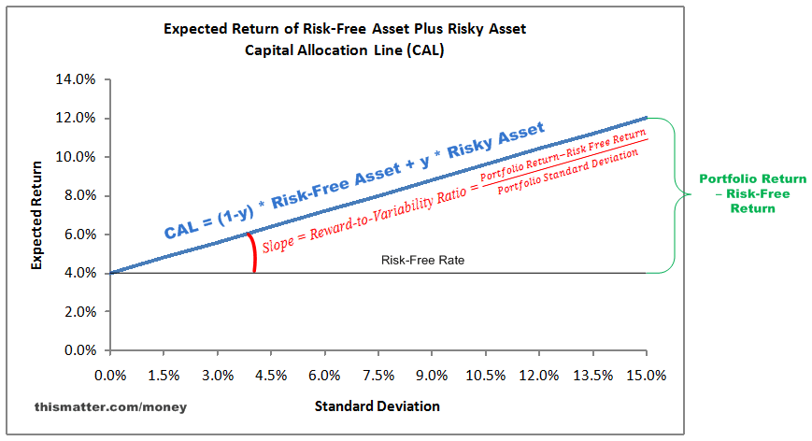The capital allocation line (CAL) is a**line created on a graph of all possible combinations of risk-free and risky assets**. The graph displays the return investors might possibly earn by assuming a certain level of risk with their investment. If too much cash is held, investment returns will tend towards the risk-free rate.

Additionally, most entrepreneurs and investors who own tangible assets use leverage to facilitate expansion.

Utilizing leverage will increase returns but a commensurate amount of risk will also be incurred.

$$Equation of the CAL: E_{RP}=R_{f}+σ_{p}\left[\frac{E_{Ri}-R_{f}}{σ_{i}}\right]$$

After analyzing your total wealth portfolio, we can recommend assets that will improve your portfolio expected return or $E_{Ri}$. This is called adding alpha. Adding assets that add alpha will steepen the slope of your capital allocation line. This means you’ll receive more return per unit of risk.

Often, in addition to improving your portfolio $E_{Ri},$ we can recommend assets that will offer the same return (or sometimes higher) but at a much lower risk level $σ_{i}$. By reducing risk while holding returns constant the slope of the CAL will steepen.

As is evidenced in the graph to the left, by improving investment returns and/or reducing risk, the client’s CAL shows an increased slope.

This means that investors will receive additional units of return for bearing the same amount of risk.